Project Report: Mystic Clothing - An Interactive E-commerce Platform with 3D Product Customization

|  |  |
| --- | --- |
|  |  |
| Name :- | BORICHA JAINISH VIJAYBHAI |
| Enrolment no :- | 23SI002UG05861 |
| Topic :- | Mystic Clothing: Interactive E-commerce |
| Guided by :- | Bhavesh Hadiyal |
| Stream :- | BCA TY |
| College :- | O.M.V.V.I.M |

Certificate

This is to certify that the project report entitled “Mystic Clothing: An Interactive E-commerce Platform with 3D Product Customization” submitted by Boricha Jainish, bearing Enrolment No. 23SI002UG05861, is a record of bona fide work carried out under my supervision and guidance. The project work is original and has not been submitted elsewhere for the award of any other degree or diploma.

Bhavesh Hadiyal

Om.V.V.I.M

Acknowledgment

Bringing the “Mystic Clothing” project from concept to a functional reality has been a challenging and deeply rewarding endeavour. This accomplishment was not achieved in isolation, and it is with profound gratitude that we acknowledge the individuals and institutions whose support was instrumental to this project's success.

First and foremost, special thanks are extended to our project guide, Bhavesh Hadiyal. Their expert guidance served as our compass throughout the development lifecycle. They provided not only the critical technical insights needed to navigate the complexities of web development and 3D graphics integration but also the strategic wisdom that kept the project focused on its core objectives. Their mentorship was invaluable.

We also express our sincere appreciation to Omvvim. The institution provided more than just academic resources; it fostered an environment of innovation and intellectual curiosity that gave us the platform to pursue this ambitious project. The encouragement to explore new technologies was a significant motivating factor.

The spirit of collaboration and knowledge sharing among our peers and friends played a pivotal role in shaping this project. The countless hours spent in discussion, debugging code, and offering mutual support were as essential to our progress as any formal guidance.

Finally, we extend our heartfelt thanks to our families for their unwavering support and patience. Their belief in our abilities and their understanding during long hours of work provided the foundational encouragement necessary to see this project through to completion.

The success of the “Mystic Clothing” platform is a reflection of the collective effort, support, and goodwill of all these individuals, and we are proud to share this achievement with them.

Project Overview

The Mystic Clothing project is a web-based e-commerce platform engineered to deliver a unique and interactive shopping experience for apparel. The system's core innovation is a client-side 3D product customization tool, which empowers users to create and visualize their own designs on clothing items in real-time. Beyond this bespoke functionality, the platform includes a comprehensive e-commerce storefront for browsing and purchasing pre-designed items, alongside a secure administrative backend for the management of products, orders, and customer data.

The online fashion industry is a highly competitive market where differentiation is key to capturing consumer interest and fostering loyalty.1 This project directly addresses this challenge by integrating a 3D customization feature, a technology at the forefront of emerging e-commerce trends.2 By allowing for a superior level of customer engagement and personalization, the platform is designed to increase sales, enhance customer satisfaction, and significantly reduce product return rates—a major operational and financial challenge in the industry.3

Built with a user-friendly front end using HTML, CSS, and JavaScript, and powered by a secure back end using PHP and MySQL, the system is both reliable and scalable. A central component is its integration with the Three.js library, which facilitates the real-time 3D rendering and texture mapping essential for the customization tool. The platform aims to serve as a robust proof-of-concept for small-to-medium-sized clothing businesses seeking to offer a distinctive and technologically advanced online shopping experience.

Index

|  |  |  |
| --- | --- | --- |
| Sr no. | Particular | Page no. |
| 1 | Project Profile |  |
|  | 1.1 Project Definition |  |
|  | 1.2 Background and Market Context |  |
|  | 1.3 Problem Statement |  |
|  | 1.4 Project Objectives |  |
|  | 1.5 Development Methodology |  |
|  | 1.6 System Process and Workflow |  |
|  | 1.7 System Requirements |  |
| 2 | System Analysis and Design |  |
|  | 2.1 Limitations of Existing Systems |  |
|  | 2.2 Scope of the Project |  |
|  | 2.3 Requirements Specification |  |
|  | 2.4 Feasibility Study |  |
|  | 2.5 Tools and Technologies Used |  |
|  | 2.6 System Architecture and Diagrams |  |
|  | 2.7 Database Design |  |
| 3 | Implementation and Testing |  |
|  | 3.1 System Screen Layouts |  |
|  | 3.2 Code Snippets with Explanation |  |
|  | 3.3 Testing Strategy and Results |  |
|  | 3.4 Bug Reports |  |
|  | 3.5 Comparison with Objectives |  |
| 4 | Conclusion and Future Work |  |
|  | 4.1 Summary of Work |  |
|  | 4.2 Challenges Faced |  |
|  | 4.3 Future Improvements |  |
|  | 4.4 References |  |
|  | 4.5 Bibliography |  |

1. Project Profile

1.1 Project Definition

The Mystic Clothing project is an interactive e-commerce platform featuring a client-side 3D rendering engine for real-time product personalization. The system provides a web-based interface where customers can select a base apparel item, upload custom graphic designs, and visualize the final product on an interactive 3D model. This core customization functionality is integrated within a standard e-commerce framework that includes user account management, a product catalog, a shopping cart, and an order processing system. The platform is supported by an administrative backend that allows for comprehensive management of inventory, customer orders, and site content. The project's primary deliverable is a fully functional proof-of-concept demonstrating the viability of integrating advanced 3D visualization tools into a scalable and secure online retail environment.1

1.2 Background and Market Context

The global online fashion industry is characterized by intense competition and evolving consumer expectations. To achieve market differentiation, brands must offer more than a simple digital catalog; they need to create engaging, personalized, and memorable shopping experiences.1 The Mystic Clothing project was conceptualized in response to this market imperative, leveraging key technological trends that are projected to define the future of e-commerce.

A primary driver in the industry is the demand for "personalization at scale".2 Modern consumers, particularly in the Gen Z and millennial demographics, increasingly expect tailored experiences and products that reflect their individual identity.5 Research indicates that 72% of consumers are more loyal to brands offering personalized experiences.6 The 3D customization feature of this project directly caters to this demand, transforming the passive act of browsing into an active process of co-creation.

Furthermore, the project's technological foundation aligns with the rapid emergence of Augmented Reality (AR) and Virtual Try-On (VTO) technologies, which are revolutionizing online shopping.2 The AR market in the US alone is projected to exceed 100 million users by 2025.6 VTO technologies, which allow customers to visualize how clothing will look on their own bodies, have been shown to increase conversion rates by as much as 94% and significantly reduce product returns.4 The 3D modelling and texture mapping pipeline developed for the Mystic Clothing customizer is a fundamental prerequisite for a full VTO implementation. By creating and manipulating 3D assets, this project serves as a vital technological stepping stone toward these more immersive AR experiences, positioning its architecture as forward-thinking and highly relevant to the future of retail.

1.3 Problem Statement

Traditional e-commerce platforms for apparel frequently suffer from a lack of engaging and interactive user experiences. Customers are typically presented with static, two-dimensional product images, which often fail to accurately convey the fit, texture, and appearance of a garment. This limitation creates a significant disconnect between customer expectations and the final product received, a primary driver of high product return rates in the fashion industry.1 High return rates are not merely an inconvenience; they represent a substantial financial burden on retailers due to reverse logistics costs and a significant environmental impact from increased shipping and waste.3

Moreover, existing customization options on many platforms are rudimentary, often limited to adding simple text or selecting from a small library of pre-set graphics. There is a clear absence of tools that allow for deep, visual personalization where a user can see a holistic, three-dimensional preview of their unique creation before committing to a purchase.

The Mystic Clothing project aims to solve this multifaceted problem by providing a robust 3D customization tool. This tool allows users to see their custom designs applied to a dynamic 3D model of the clothing item, bridging the gap between digital visualization and physical reality. By offering a more accurate and engaging preview, the system is designed to increase buyer confidence, enhance customer satisfaction, and directly mitigate the financial and environmental costs associated with high return rates.

1.4 Project Objectives

The development of the Mystic Clothing platform was guided by a set of specific, measurable, and technically-focused objectives designed to ensure the creation of a robust and functional system.

To implement a client-side 3D rendering module: Develop an interactive 3D viewer using the Three.js library that allows users to apply custom texture maps (from user-uploaded PNG/JPG images) to a predefined 3D clothing model in real-time.

To develop a secure e-commerce storefront: Create a platform where customers can register, log in, browse a product catalog, search for items, and view product details.

To build a secure, session-based transaction system: Implement a functional shopping cart that allows users to add, update, and remove items, and a seamless checkout process for processing personalized product orders.

To create a role-based administrative backend: Design and develop a secure admin panel that enables administrators to perform Create, Read, Update, and Delete (CRUD) operations on products, manage inventory levels, and view and fulfil customer orders.

To ensure a responsive and accessible user interface: Design the website to be fully responsive, ensuring accessibility and optimal user experience across a range of devices and screen sizes, from mobile phones to desktops.

To establish a normalized and efficient database schema: Design and implement a relational database in MySQL that is normalized to at least Third Normal Form (3NF) to ensure data integrity, eliminate redundancy, and support scalable application performance.

1.5 Development Methodology

The project was developed using a structured, phased methodology that emphasizes modular development, iterative testing, and clear documentation at each stage. This approach, adapted from the benchmark model 1, ensures a systematic progression from concept to deployment.

Requirement Gathering & Analysis:

This initial phase involved defining the core features and functionalities of the platform. User stories were created for the two primary actors: the "Customer" (e.g., "As a customer, I want to upload my own image to put on a T-shirt") and the "Administrator" (e.g., "As an administrator, I want to add a new product with its price and quantity").

System Design & Planning:

The architectural blueprint for the system was created. This included designing the three-tier architecture (client, server, database), defining the database schema with all tables and relationships, and creating wireframes for the user interface (UI) and user experience (UX) flow.

Technology Framework Selection:

A technology stack was chosen based on the project requirements. PHP was selected for its robust server-side scripting capabilities and widespread support. MySQL was chosen for its reliability as a relational database management system. For the core feature, Three.js was selected as the 3D rendering library due to its extensive documentation, strong community support, and native WebGL capabilities, which eliminate the need for browser plugins.1

Development Phase (Modular):

The implementation was broken down into distinct modules that were developed in parallel where possible. These modules included: (a) the user authentication system, (b) the e-commerce storefront and product display, (c) the 3D customization engine, (d) the shopping cart and checkout logic, and (e) the administrative backend.

Testing & Validation:

A comprehensive testing strategy was executed to ensure quality and reliability. This included unit testing for individual functions (e.g., database connection), integration testing to ensure modules worked together seamlessly (e.g., adding a customized item to the cart), and usability testing to gather feedback on the user interface.

Deployment:

The completed application was deployed to a local development server environment using XAMPP, which bundles an Apache web server, MySQL database, and PHP. This allowed for a realistic simulation of a live hosting environment for final testing and demonstration.

Maintenance & Future Roadmap:

The final phase involved documenting the project thoroughly and outlining a strategic roadmap for future enhancements and scalability, as detailed in the "Future Improvements" section of this report.

1.6 System Process and Workflow

The primary user journey through the Mystic Clothing platform is designed to be intuitive and seamless, guiding the customer from product discovery through customization to final purchase. The workflow is structured as follows:

User Authentication:

The process begins with the customer either registering for a new account or logging into an existing one. Secure authentication is managed via a session-based system.

Product Selection:

The customer navigates the "Shop" page to browse the catalog of available apparel. Upon finding an item designated as customizable, they select it to proceed to the customization stage.

3D Customization:

The user is directed to the interactive 3D design interface (design3d.php). Here, they are presented with a 3D model of the selected clothing item. The interface provides controls to upload their own graphic images (e.g., PNG, JPG) and apply them as textures to different surfaces of the model (e.g., front, back). The user can rotate, pan, and zoom the 3D model to view their design from all angles.

Design Submission and Saving:

Once satisfied with their creation, the user saves the design. In the backend, the system processes the uploaded images, saves them to a designated server directory with unique filenames, and creates a new entry in the designs database table, linking the design files to the customer's user ID.

Add to Cart & Checkout:

The newly created personalized product is added to the user's shopping cart. The cart displays the item, quantity, and price. The user then proceeds to the checkout page, where they enter shipping and billing information to complete the order.

Administrative Order Fulfillment:

Upon successful order placement, a new record is created in the orders table. An administrator, logged into the secure admin panel, can view this new order. The order details include a reference to the specific design ID, allowing the administrator to retrieve the customer's unique design files from the server to begin the physical production and fulfillment process.

1.7 System Requirements

To ensure the proper functioning and accessibility of the Mystic Clothing platform, the following software and hardware requirements have been defined for both the server (development) and client (user) sides.

Software Requirements

Server-Side (Development Environment):

|  |  |
| --- | --- |
| Component | Minimum Requirement |
| Operating System | Windows, macOS, or Linux |
| Web Server | Apache 2.4 or later |
| Backend Language | PHP 7.4 or later |
| Database | MySQL 5.7 or MariaDB 10.4 or later |
| Development Tools | VS Code, Git for version control |
| Local Server Stack | XAMPP / WAMP / MAMP |

Client-Side (User Environment):

|  |  |
| --- | --- |
| Component | Minimum Requirement |
| Operating System | Any modern OS (Windows, macOS, Linux, Android, iOS) |
| Web Browser | A modern browser with JavaScript and WebGL support (e.g., Chrome, Firefox, Safari, Edge) |
| Internet Connection | Stable broadband connection for asset loading |

Hardware Requirements :

Server-Side (Development Environment):

|  |  |
| --- | --- |
| Component | Minimum Requirement |
| Processor | Intel Core i3 or equivalent |
| RAM | 4 GB or more |
| Storage | 20 GB free disk space |

Client-Side (User Environment):

|  |  |
| --- | --- |
| Component | Minimum Requirement |
| Device | Desktop, Laptop, Tablet, or Smartphone |
| Processor | Modern dual-core processor |
| Graphics | A GPU capable of supporting WebGL for 3D rendering |
| RAM | 2 GB or more |

2. System Analysis and Design

2.1 Limitations of Existing Systems

Many existing e-commerce platforms for small-to-medium apparel businesses, particularly those built on simple templates or legacy systems, exhibit significant limitations that hinder their competitiveness and user satisfaction. These limitations informed the core design principles of the Mystic Clothing project.1

Static and Unrepresentative Product Visualization:

The most common limitation is the reliance on static 2D product images. These images often fail to capture the true fit, drape, and texture of a garment, leading to a gap between what the customer sees online and what they receive. This directly contributes to higher return rates.4

Rudimentary Customization Capabilities:

When customization is offered, it is frequently confined to basic options such as adding pre-set text or choosing from a limited library of clipart-style graphics. These systems lack the flexibility for users to upload and visualize their own unique, complex designs.

Passive and Unengaging User Experience:

The shopping journey on these platforms is often a passive, transactional process of browsing and clicking. There is little to no opportunity for interactive engagement, which can lead to lower user retention and brand loyalty in a market where experience is paramount.1

Inability to Mitigate "Fit Uncertainty":

A major pain point in online apparel shopping is the uncertainty about how an item will fit. Traditional systems offer no solution to this beyond static size charts, a problem that more advanced technologies like AR and VTO are now beginning to solve.8

2.2 Scope of the Project

The scope of the Mystic Clothing project is to develop a fully functional, proof-of-concept e-commerce website that demonstrates the successful integration of a 3D product customization tool. The project's boundaries are defined by the following key areas:

In Scope:

Customer-Facing Website:

This includes all functionalities required for a complete shopping experience: user registration and login, a product catalog with search and filtering, the interactive 3D design tool, a persistent shopping cart, and a multi-step checkout process.

Administrative Panel:

A secure, role-based backend providing administrators with the tools for managing products (adding, editing, deleting inventory) and processing customer orders (viewing order details and associated custom designs).

Database Management:

The design and implementation of a relational database to store all necessary data for customers, products, user-generated designs, and orders.

3D Customization Engine:

The core functionality allowing users to upload image files and apply them as textures to a 3D model of a garment within the browser.

Out of Scope:

Real-Time Payment Gateway Integration:

The checkout process simulates a successful transaction but does not integrate with live payment gateways like Stripe or PayPal for actual financial processing.

Shipping and Logistics Management:

The system does not include modules for calculating shipping costs, generating shipping labels, or tracking shipments.

Advanced AI-Based Features:

The initial implementation does not include advanced features such as AI-powered product recommendations, automated trend analysis, or generative AI design tools. These are identified as future enhancements.

Multiple 3D Models:

The proof-of-concept focuses on a single, representative 3D clothing model (e.g., a T-shirt) to demonstrate the customization technology.

2.3 Requirements Specification

A detailed specification of functional and non-functional requirements was established to guide the development process and serve as a benchmark for testing and validation.

Functional Requirements :

FR-01:

User Registration: The system shall allow new users to create an account by providing a name, email address, and a password.

FR-02:

User Login: Registered users shall be able to log into the system using their email and password. The system shall maintain user sessions.

FR-03:

Product Catalog: The system shall display all available products in a grid or list format on a "Shop" page.

FR-04:

Product Management (Admin): An authenticated administrator shall be able to add, view, update, and delete product listings in the inventory, including name, price, quantity, and image.

FR-05:

3D Model Loading: The system shall load a pre-defined 3D model of a clothing item into an interactive viewer on the customization page.

FR-06:

Image Upload: The system shall provide an interface for the user to upload a PNG or JPG image file from their local device.

FR-07:

Real-Time Texture Application: The system shall apply the user-uploaded image as a texture map to the designated surface (e.g., front) of the 3D model in real-time.

FR-08:

Design Saving: The system shall allow a user to save their finalized design, storing the uploaded image file on the server and creating a corresponding record in the database linked to their user account.

FR-09:

Shopping Cart Management: Users shall be able to add customized and standard products to a shopping cart, view the cart's contents, and update item quantities.

FR-10:

Order Placement: The system shall guide the user through a checkout process to place an order for the items in their cart.

FR-11:

Order Management (Admin): An administrator shall be able to view a list of all customer orders, including customer details and references to any custom designs associated with the order.

Non-Functional Requirements :

NFR-01:

Performance: The main shop page shall load in under 2 seconds. The 3D rendering interface, including the 3D model, shall load in under 3 seconds on a standard broadband connection.

NFR-02: Security:

All user passwords must be stored in the database using a strong, one-way hashing algorithm (e.g., SHA-256 or bcrypt). The admin panel must be protected from unauthorized access.

NFR-03: Usability:

The user interface shall be intuitive and easy to navigate for non-technical users. All interactive elements shall have clear labels and affordances.

NFR-04: Reliability:

The system shall process transactions accurately, ensuring that a saved design correctly corresponds to the final order.

NFR-05: Compatibility:

The website shall be rendered correctly and remain fully functional on the latest versions of major web browsers, including Google Chrome, Mozilla Firefox, and Apple Safari.

NFR-06: Scalability:

The database schema and application logic shall be designed to handle a growing number of users, products, and orders without significant degradation in performance.

NFR-07: Responsiveness:

The website layout shall adapt fluidly to different screen sizes, providing a consistent and usable experience on desktops, tablets, and mobile devices with screen widths from 360px to 1920px.

2.4 Feasibility Study

A comprehensive feasibility study was conducted to assess the viability of the Mystic Clothing project across five key dimensions, ensuring that the project was practical, cost-effective, and legally sound.

Technical Feasibility:

The project is technically feasible. The chosen technology stack—comprising PHP for the backend, MySQL for the database, and HTML/CSS/JavaScript for the frontend—is well-established, widely supported, and proven for building robust web applications.1 The core technical challenge, the 3D customization tool, is addressed using Three.js, a mature and powerful JavaScript library for creating and displaying 3D computer graphics in a web browser. The existence of extensive documentation and community support for Three.js confirms that the implementation of the required features is achievable within the scope of the project.

Economic Feasibility:

The project is highly cost-effective. The reliance on open-source technologies (PHP, MySQL, Apache, Three.js) eliminates software licensing fees, which are often a significant cost factor in development projects. The primary financial outlays would be for web hosting and a domain name, both of which are readily available at low cost. Development can be performed using free and open-source tools like Visual Studio Code, further minimizing expenditure. This low financial barrier makes the project economically viable for a student project or a small business proof-of-concept.1

Operational Feasibility:

The system is designed to be operationally feasible for its intended users. The customer-facing website features a standard and intuitive e-commerce workflow, requiring no special training. The administrative panel is designed with a user-friendly graphical interface, allowing non-technical staff to manage products and orders efficiently. The clear separation of roles ensures that daily operations can be conducted smoothly without requiring deep technical expertise.1

Legal Feasibility:

The project operates within a legally feasible framework, though it requires attention to specific areas. The system must comply with data privacy regulations (such as GDPR or local equivalents) regarding the collection and storage of customer data. A privacy policy would be required for a live deployment. A significant legal consideration is the intellectual property of user-uploaded designs. The terms of service for a live platform would need to clearly state the ownership and usage rights of these designs to avoid copyright disputes.

Schedule Feasibility:

The project can be realistically completed within a timeframe of 3–4 months. By adopting a modular development approach as outlined in the methodology, different components (e.g., user authentication, product catalog, 3D viewer) can be developed and tested concurrently. This parallel workflow reduces dependencies and mitigates the risk of delays, ensuring that project milestones can be met and the final system can be delivered in a timely manner.

2.5 Tools and Technologies Used :

The Mystic Clothing platform is built using a carefully selected stack of client-side and server-side technologies, supported by standard development and deployment tools. Each component was chosen to meet the specific functional and non-functional requirements of the project.

Front-End (Client-Side)

HTML:

Provides the fundamental structure and semantic markup for all web pages.

CSS:

Used for styling the visual presentation of the user interface, including layout, colors, and typography, to create a visually appealing and brand-consistent experience.

JavaScript:

Adds interactivity and dynamic functionality to the client-side. It is responsible for handling user events, form validation, and asynchronous communication with the server (AJAX).

Babylon.js:

A powerful JavaScript framework used to create and render high-performance 3D graphics in the browser using WebGL. It serves as the core engine for the 3D product customization tool, managing the rendering of the 3D model, camera interactions, lighting, and the dynamic application of user-uploaded images as textures.

Back-End (Server-Side)

PHP:

The server-side scripting language responsible for processing all business logic. This includes handling user authentication, managing sessions, interacting with the database, processing form submissions, and saving user-uploaded design files.

MySQL:

A robust and widely-used relational database management system (RDBMS) that serves as the data persistence layer for the application. It stores all critical data, including customer information, product inventory, design metadata, and order details.

Supporting Tools

Apache:

The web server used to host the application, handle HTTP requests from clients, and serve the application's files.

PHPMailer:

A third-party PHP library used for handling email functionalities, such as sending order confirmations or password reset emails.

Visual Studio Code:

The primary integrated development environment (IDE) used for writing, editing, and debugging the application's code.

Git:

The version control system used to track changes in the source code, facilitate collaboration, and manage the project's history.

XAMPP:

A local server stack used for development and testing, providing an integrated environment with Apache, MySQL, and PHP.

2.6 System Architecture and Diagrams

2.6.1 System Architecture Overview

The Mystic Clothing platform is designed using a classic three-tier architecture, a well-established software architecture pattern that separates the application into logical and physical computing tiers. This separation enhances scalability, maintainability, and flexibility.

Presentation Tier (Client-Side):

This is the user interface that runs in the client's web browser. It is built using HTML, CSS, and JavaScript. This tier is responsible for displaying information to the user and capturing their input. The most complex component of this tier is the 3D customization interface, which leverages the Three.js library and WebGL to handle all 3D rendering directly on the client's machine.

Application Tier (Server-Side):

This tier contains the business logic of the application. It is hosted on a web server (Apache) and implemented using PHP. It processes requests from the presentation tier, interacts with the database to retrieve or store data, handles user sessions, and manages file uploads for custom designs.

Data Tier (Database):

This tier consists of the MySQL database server. It is responsible for the persistent storage and management of all application data, including user accounts, product inventory, order history, and metadata for custom designs. The application tier communicates with this tier via SQL queries.

2.6.2 Data Flow Diagrams (DFD)

Data Flow Diagrams are used to represent the flow of data through the system.

Level 0 DFD (Context Diagram):

The Level 0 diagram provides a high-level overview of the entire system as a single process. It would show the "Mystic Clothing System" at the center. Two external entities would interact with it: the Customer, who provides login credentials, personal data, uploaded designs, and order information, and receives product information and order confirmations; and the Administrator, who provides product data and management commands, and receives order reports and inventory status.

Level 1 DFD:

The Level 1 diagram breaks down the main process into its major sub-processes. It would show the following key processes:

1.0 Manage User Accounts:

Handles customer registration and login, interacting with the customer data store.

2.0 Manage Inventory:

Used by the Administrator to perform CRUD operations on products, interacting with the inventory data store.

3.0 Process Custom Design:

Handles the user's interaction with the 3D customizer, including image uploads and saving design data to the designs data store.

4.0 Manage Orders:

Manages the shopping cart, checkout process, and order fulfillment, interacting with the orders, customer, inventory, and designs data stores.

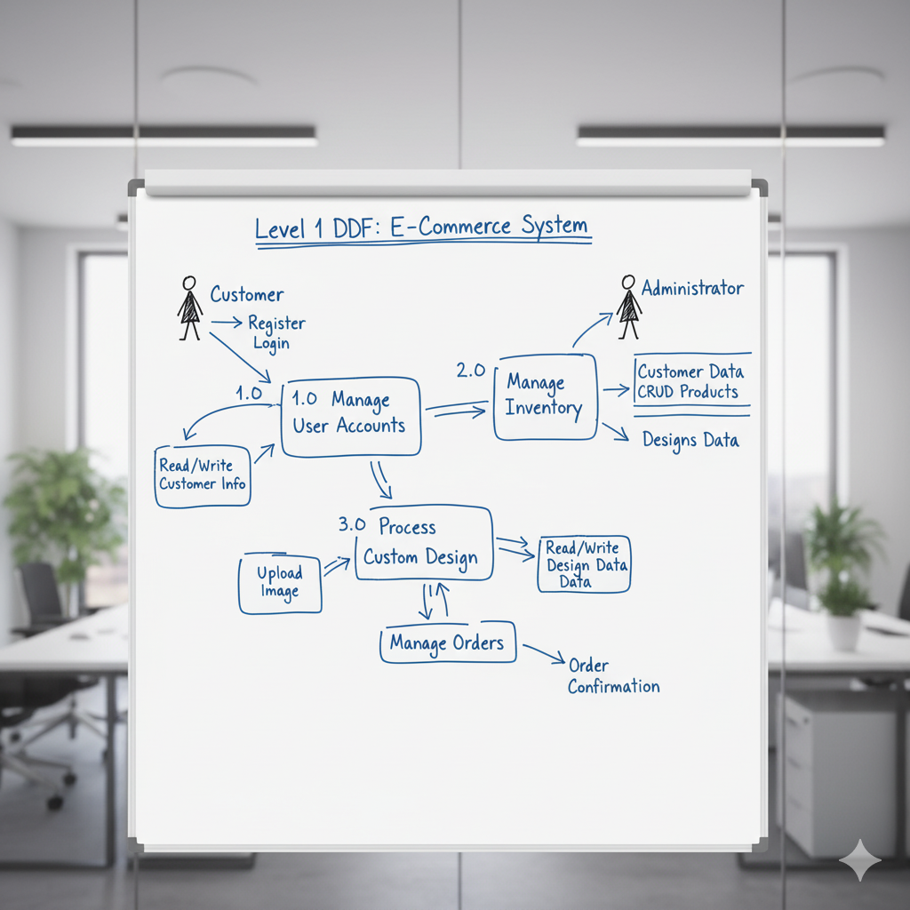

2.6.3 UML Diagrams

UML diagrams are used to visualize the design of the system from different perspectives.

Use Case Diagram:

This diagram illustrates the interactions between the actors (users) and the system.

Actors:

Customer, Administrator.

Customer Use Cases:

Register, Login, Browse Products, Search Products, Customize Product, Add to Cart, Place Order, View Order History.

Administrator Use Cases:

Login, Manage Products, Manage Orders, View Customers.

Relationships:

The "Customize Product" use case would be a central and unique feature linked to the Customer actor.

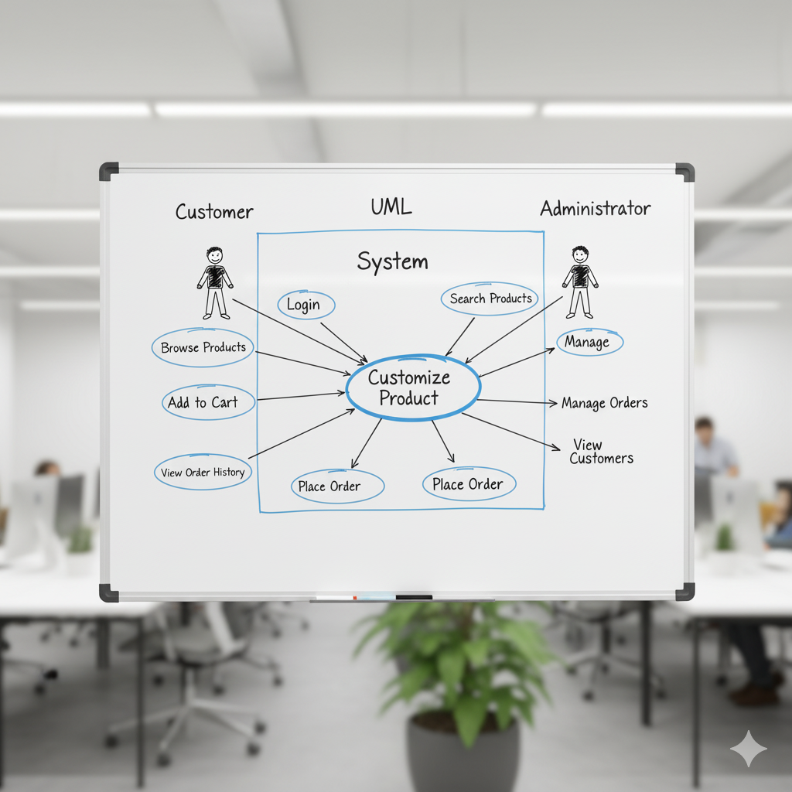

Class Diagram:

This diagram provides a static view of the system's structure by showing its classes (which correspond to the database tables) and their relationships.

Classes:

Customer, Admin, Inventory (Product), Designs, Orders, Billing.

Relationships:

A Customer can have many Orders (one-to-many).

A Customer can create many Designs (one-to-many).

An Order is associated with one Customer, one Design (if customized), and one Inventory item (one-to-one relationships via foreign keys).

An Order has one Billing record (one-to-one).

This diagram visually represents the foreign key constraints and cardinality of the database schema.

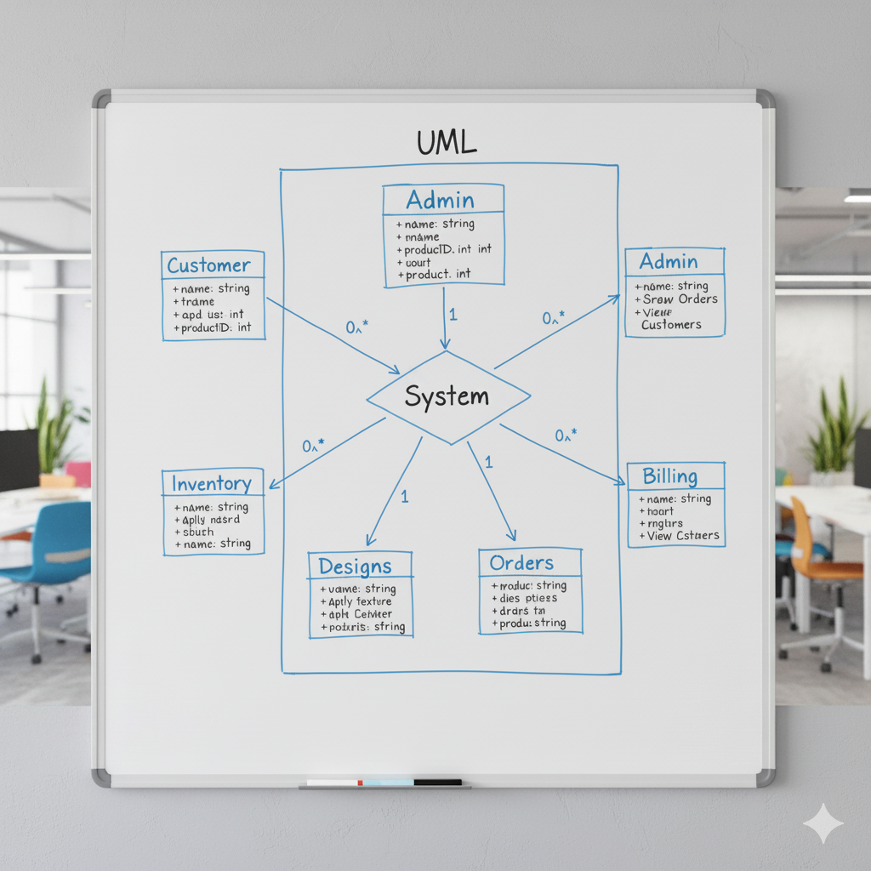

Activity Diagram:

This diagram models the dynamic aspects of the system by showing the flow of control from one activity to another. An activity diagram for the "Customize and Purchase Product" workflow would illustrate the following steps:

* Starts with the user selecting a product.
* A decision node checks if the product is customizable.
* If yes, the flow moves to the "Open 3D Customizer" activity.
* The user performs "Upload Image" and "Apply Texture" activities.
* After saving the design, the flow moves to "Add Item to Cart."
* The user proceeds to "Checkout," fills in "Shipping Details," and "Confirms Order."
* The flow concludes with the system "Processing the Order" and displaying a confirmation.

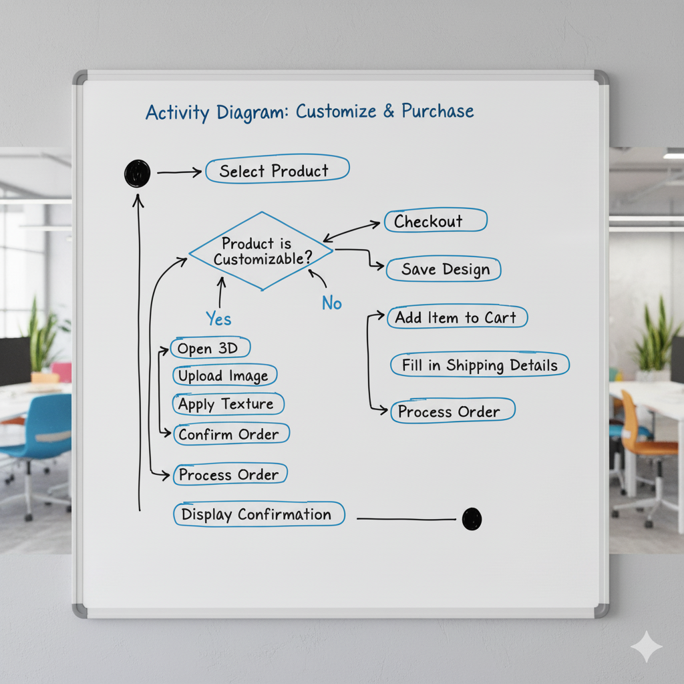

2.7 Database Design

2.7.1 Data Dictionary

The database for the Mystic Clothing platform is composed of several interconnected tables designed to store information about customers, administrators, products, designs, and orders efficiently.

1. Table: customer (Stores registered customer information)

|  |  |  |  |
| --- | --- | --- | --- |
| Field Name | Description | Data Type | Constraints |
| customer_id | Unique identifier for the customer | INT (11) | Primary Key, Auto Increment |
| name | The full name of the customer | VARCHAR (100) | Not Null |
| email | The email address of the customer, used for login | VARCHAR (100) | Unique, Not Null |
| phone | The contact phone number of the customer | VARCHAR (15) | Nullable |
| address | The primary shipping address of the customer | TEXT | Nullable |
| password | The customer's securely hashed password | VARCHAR (255) | Not Null |
| Created_at | Timestamp of when the account was created | TIMESTAMP | Default: CURRENT_TIMESTAMP |
| reset_token_hash | A unique token for password reset requests | VARCHAR (64) | Unique, Nullable |
| reset_token_expires_at | Expiry time for the password reset token | DATETIME | Nullable |

2. Table: admin (Stores administrator login credentials)

|  |  |  |  |
| --- | --- | --- | --- |
| Field Name | Description | Data Type | Constraints |
| admin_id | Unique identifier for the admin | INT (11) | Primary Key, Auto Increment |
| name | The name of the administrator | VARCHAR (100) | Not Null |
| email | The email address of the administrator | VARCHAR (100) | Unique, Not Null |
| role | The role of the administrator (e.g., 'superadmin') | VARCHAR (50) | Nullable |
| password | The admin's securely hashed password | VARCHAR (255) | Not Null |

3. Table: inventory (Stores product information)

|  |  |  |  |
| --- | --- | --- | --- |
| Field Name | Description | Data Type | Constraints |
| inventory_id | Unique identifier for the product | INT (11) | Primary Key, Auto Increment |
| product_name | The name of the product | VARCHAR (100) | Not Null |
| stock_qty | The quantity of the product currently in stock | INT (11) | Default: 0 |
| material_type | The material of the product (e.g., 'Cotton') | VARCHAR (50) | Nullable |
| price | The price of the product | DECIMAL (10,2) | Not Null |
| image_url | The file path for the main product image | VARCHAR (255) | Default: 'image/placeholder.png' |

4. Table: designs (Stores metadata for user-created designs)

|  |  |  |  |
| --- | --- | --- | --- |
| Field Name | Description | Data Type | Constraints |
| design_id | Unique identifier for the design | INT (11) | Primary Key, Auto Increment |
| customer_id | Foreign key referencing the customer who created it | INT (11) | Foreign Key (customer. customer_id) |
| design_file | File path for the front design image | VARCHAR (255) | Not Null |
| design_file_back | File path for the back design image | VARCHAR (255) | Nullable |
| design_type | Type of design (e.g., 'custom', 'standard') | VARCHAR (50) | Nullable |
| created_at | Timestamp of when the design was created | DATETIME | Default: CURRENT_TIMESTAMP |

5. Table: orders (Stores information about customer orders)

|  |  |  |  |
| --- | --- | --- | --- |
| Field Name | Description | Data Type | Constraints |
| order_id | Unique identifier for the order | INT (11) | Primary Key, Auto Increment |
| customer_id | Foreign key referencing the customer who placed the order | INT (11) | Foreign Key (customer. customer_id) |
| design_id | Foreign key referencing the associated design | INT (11) | Foreign Key (designs.design_id) |
| inventory_id | Foreign key referencing the product ordered | INT (11) | Foreign Key (inventory. inventory_id) |
| order_date | The date when the order was placed | DATE | Nullable |
| status | The current status of the order (e.g., 'Pending') | VARCHAR (50) | Default: ‘Pending’ |

6. Table: billing (Stores billing information for each order)

|  |  |  |  |
| --- | --- | --- | --- |
| Field Name | Description | Data Type | Constraints |
| billing_id | Unique identifier for the billing entry | INT (11) | Primary Key, Auto Increment |
| customer_id | Foreign key referencing the customer | INT (11) | Foreign Key (customer. customer_id) |
| order_id | Foreign key referencing the associated order | INT (11) | Foreign Key (orders. order_id) |
| amount | The total amount of the order | DECIMAL (10,2) | Not Null |
| payment_method | The payment method used (e.g., 'Credit Card') | VARCHAR (50) | Nullable |
| status | The payment status (e.g., 'Paid', 'Unpaid') | VARCHAR (50) | Default: 'Unpaid' |
| billing_date | The date of the billing transaction | DATE | Nullable |

2.7.2 Normalization Analysis :

The database schema for the Mystic Clothing project has been designed following the principles of database normalization to ensure data integrity, reduce redundancy, and improve overall database performance. The schema achieves at least the Third Normal Form (3NF).

First Normal Form (1NF):

The schema adheres to 1NF.

Rule:

Each table cell must contain a single, atomic value, and each record must be unique.

Analysis:

All columns in every table (e.g., customer, inventory, orders) are designed to hold atomic values. For example, the address field holds a single text block, not separate repeating columns for street, city, etc. Each table has a primary key that ensures the uniqueness of every record. There are no repeating groups or multi-valued attributes.

Status:

Achieved.

Second Normal Form (2NF):

The schema adheres to 2NF.

Rule:

The schema must be in 1NF, and all non-key attributes must be fully functionally dependent on the entire primary key. This rule is primarily relevant for tables with composite primary keys.

Analysis:

All primary keys in the schema (customer_id, inventory_id, etc.) are single-column keys. Therefore, the issue of partial dependency (where a non-key attribute depends on only part of a composite key) is not applicable. All non-key attributes in each table are fully dependent on their respective single-column primary key. For example, in the inventory table, product_name and price are dependent on inventory_id, not on any other attribute.

Status:

Achieved.

Third Normal Form (3NF):

The schema adheres to 3NF.

Rule:

The schema must be in 2NF, and there must be no transitive dependencies (where a non-key attribute depends on another non-key attribute).

Analysis:

The schema has been designed to eliminate transitive dependencies. For example, in the orders table, attributes like order_date and status depend directly on the primary key order_id. Customer information is not stored directly in the orders table; instead, a foreign key customer_id is used. This prevents a situation where, for instance, a customer's name (a non-key attribute) would depend on customer_id (another non-key attribute within the orders table), which in turn depends on the primary key order_id. By separating entities into their own tables (customer, inventory, designs), all attributes are made directly dependent on their table's primary key, thus satisfying 3NF.

Status: Achieved.

3. Implementation and Testing

3.1 System Screen Layouts

The following figures illustrate the key user interfaces of the Mystic Clothing platform, showcasing the workflow from the main landing page to the administrative backend.

Figure 3.1: Homepage (Main.php)

This is the main landing page of the website. It features the primary navigation bar, a hero section with a call-to-action to encourage exploration, and sections for featured products or ongoing promotions.

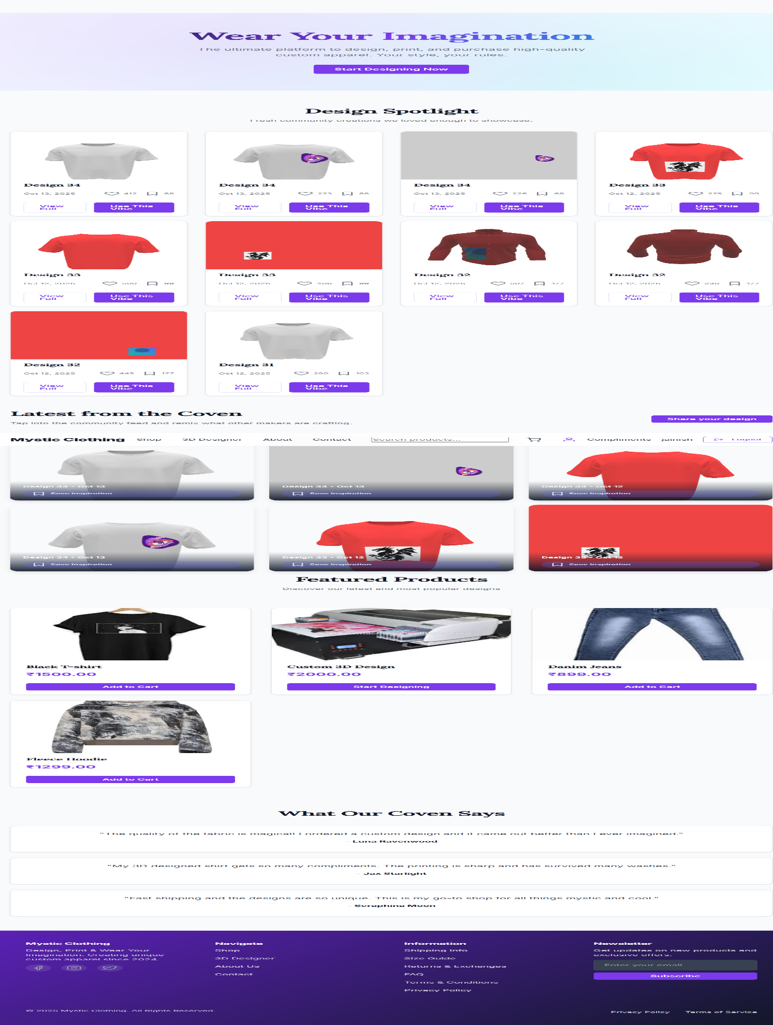

Figure 3.2: Shop Page (shop.php)

This page displays a grid of all available products from the inventory. Each product card shows an image, name, and price. Users can click on any product to view more details or begin the customization process.

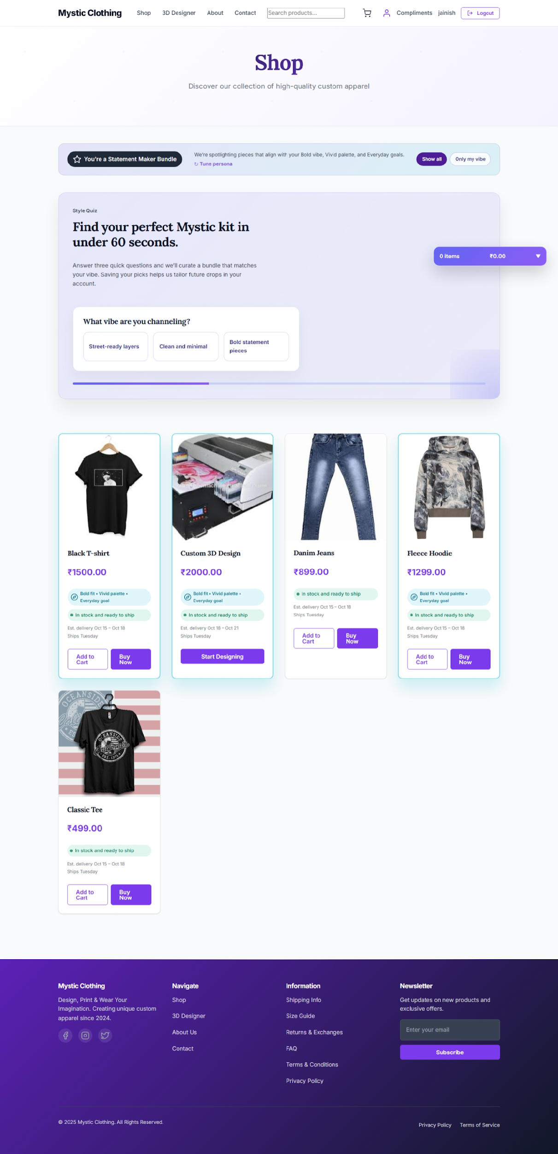

Figure 3.3: 3D Design Page (design3d.php)

This is the core interactive feature of the platform. The page is dominated by the 3D viewer displaying a model of a T-shirt. On the side, controls are provided for uploading a custom image, applying it to the model, and manipulating the 3D view (rotate, pan, zoom).

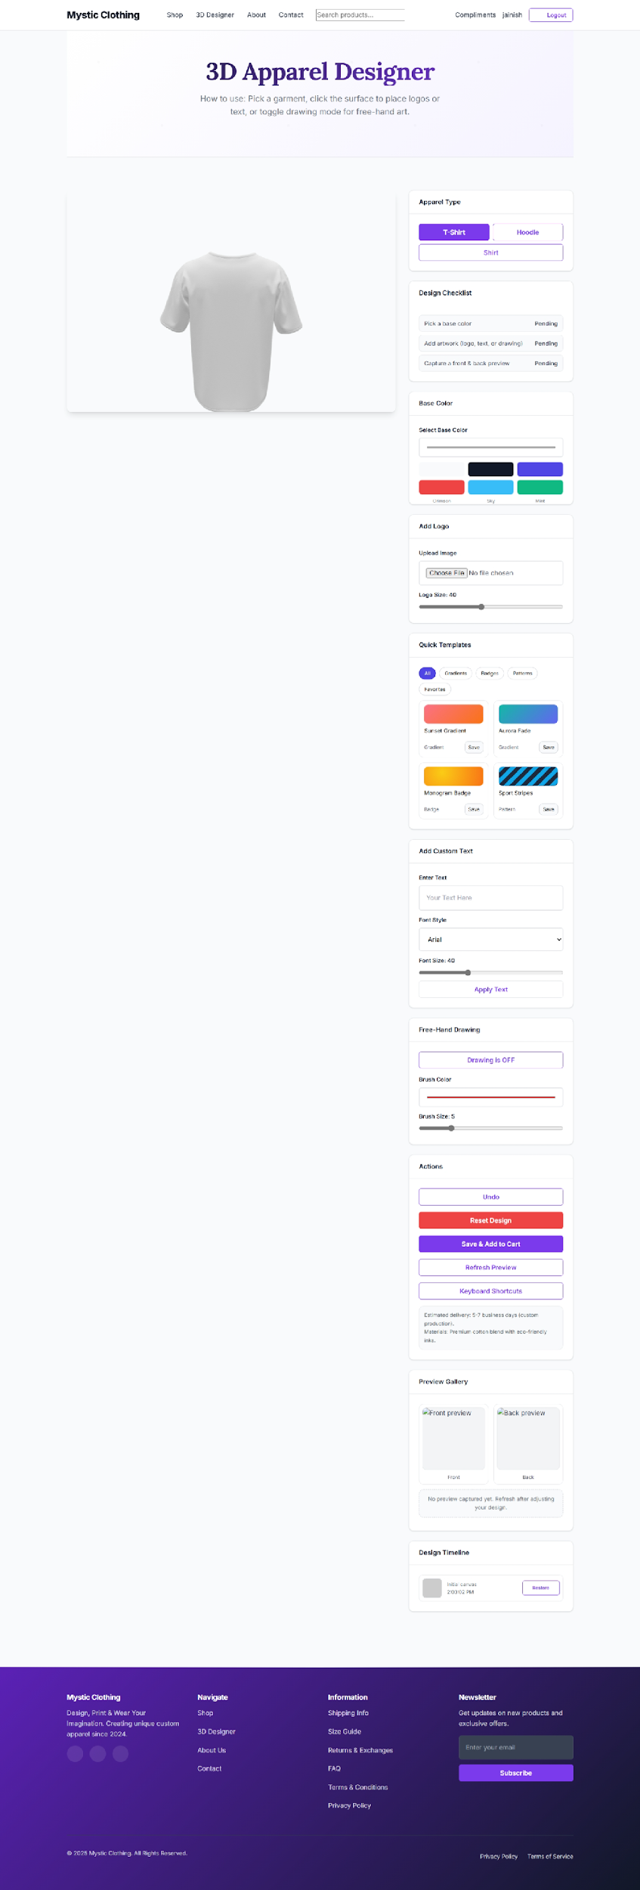

Figure 3.4: Shopping Cart (cart.php)

This page provides a summary of all items the user has added to their cart. It displays the product, quantity, and price for each item, along with a subtotal. Users have options to update quantities or remove items before proceeding to checkout.

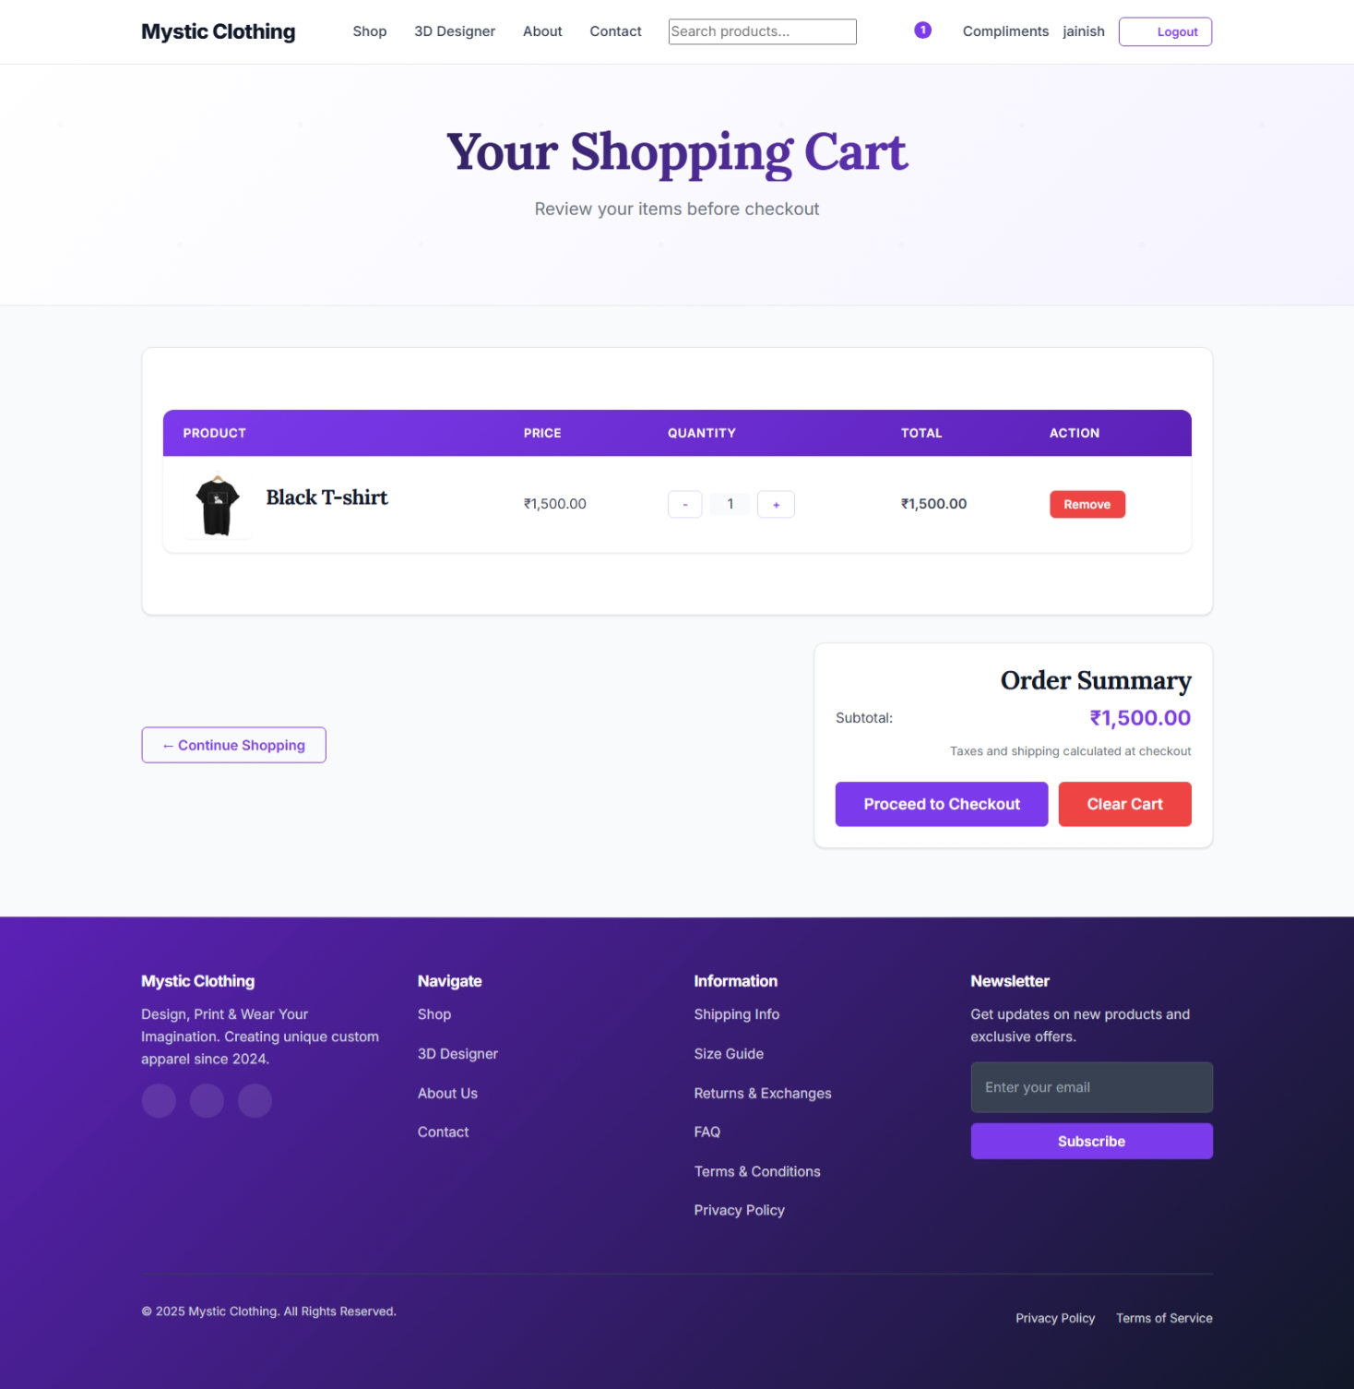

Figure 3.5: Checkout Page (checkout.php)

This is the final step in the purchasing process. It presents a form for the user to enter their shipping and billing information to complete the purchase.

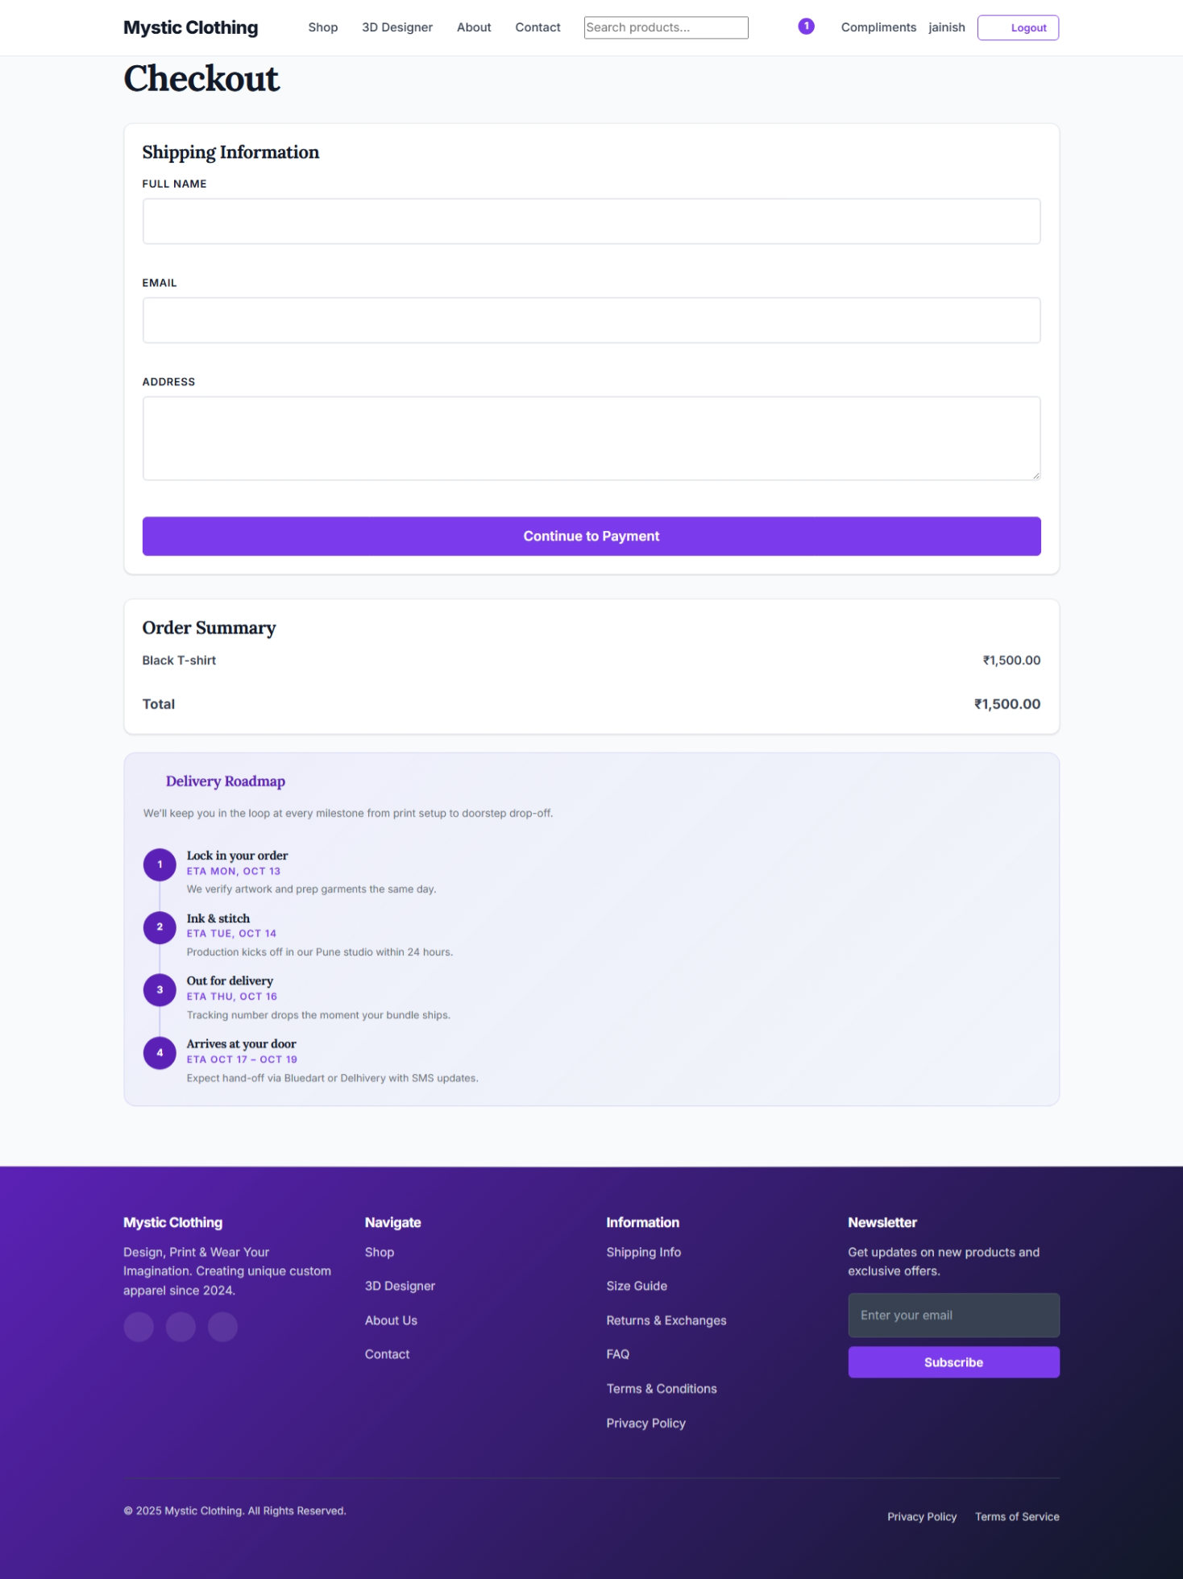

Figure 3.6: Admin Dashboard (admin/dashboard.php)

This is the main landing page for the administrative panel. It provides a high-level overview of the store's activity, including metrics for recent orders, total sales, and other key performance indicators.

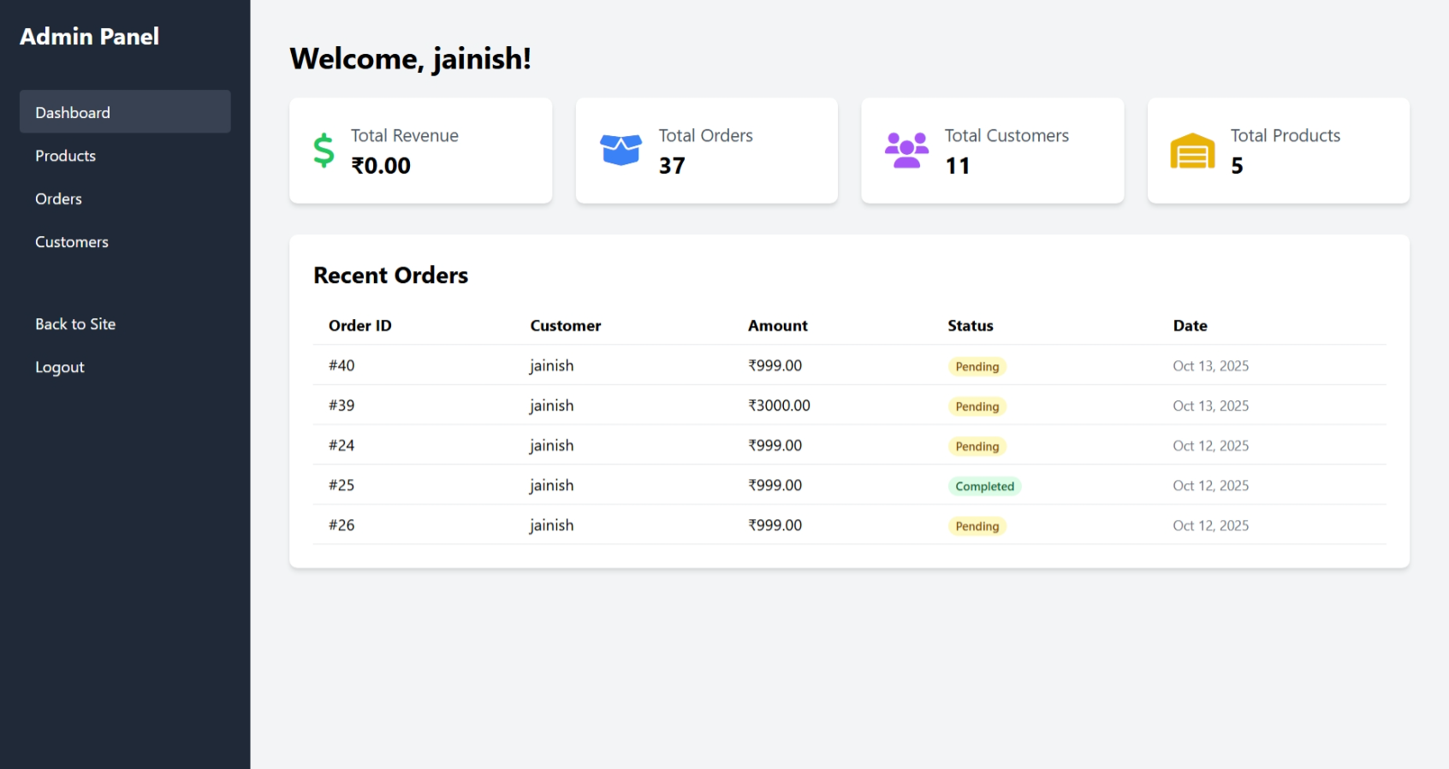

Figure 3.7: Admin Products Management Page (admin/products.php)

This interface presents a comprehensive table listing all products in the inventory. It provides administrators with the functionality to add new products, edit existing product details (name, price, quantity), or delete products from the store.

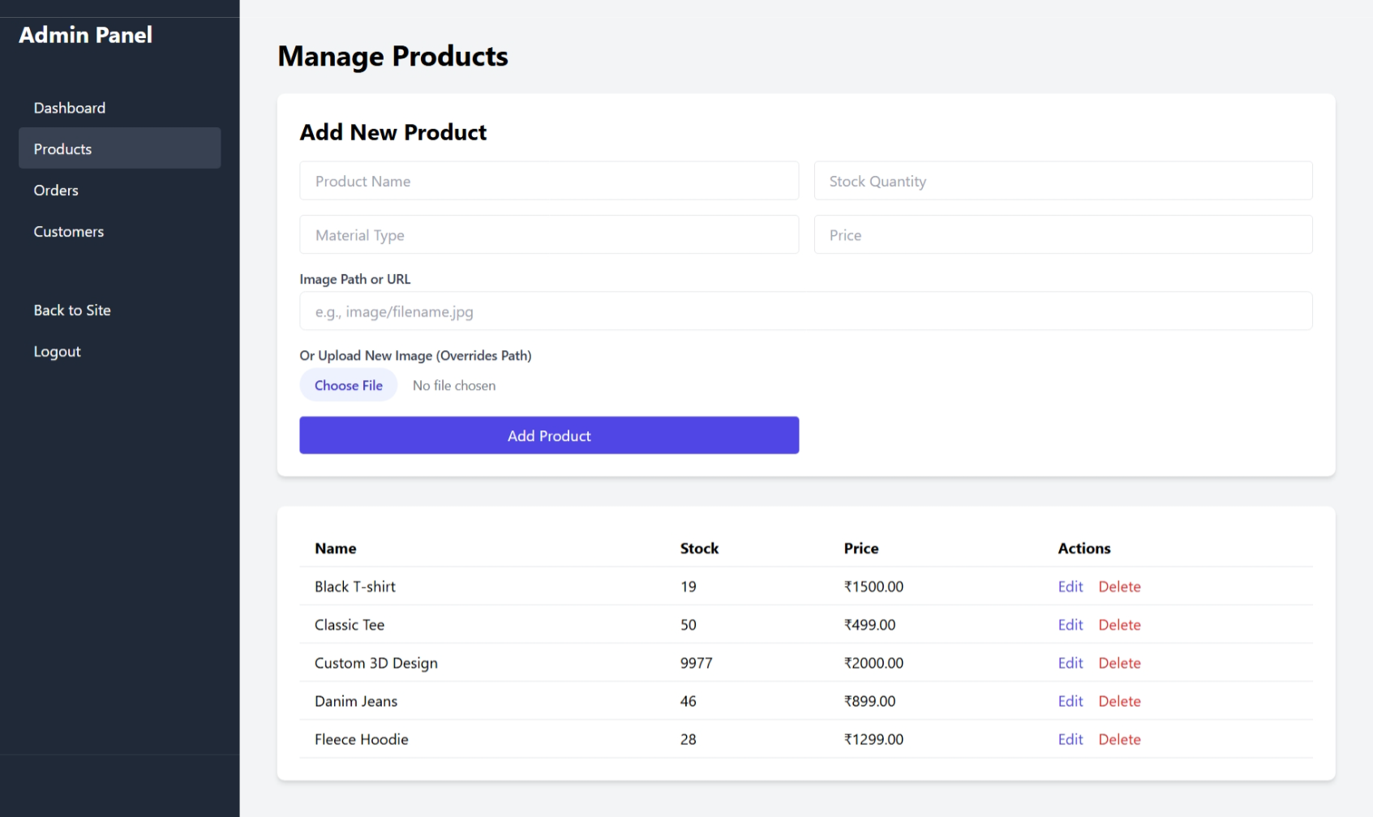

Figure 3.8: Admin Orders Management Page (admin/orders.php)

This page displays a table of all customer orders. Each row provides details about the order, including the customer's name, the products ordered, the total amount, and the current status of the order.

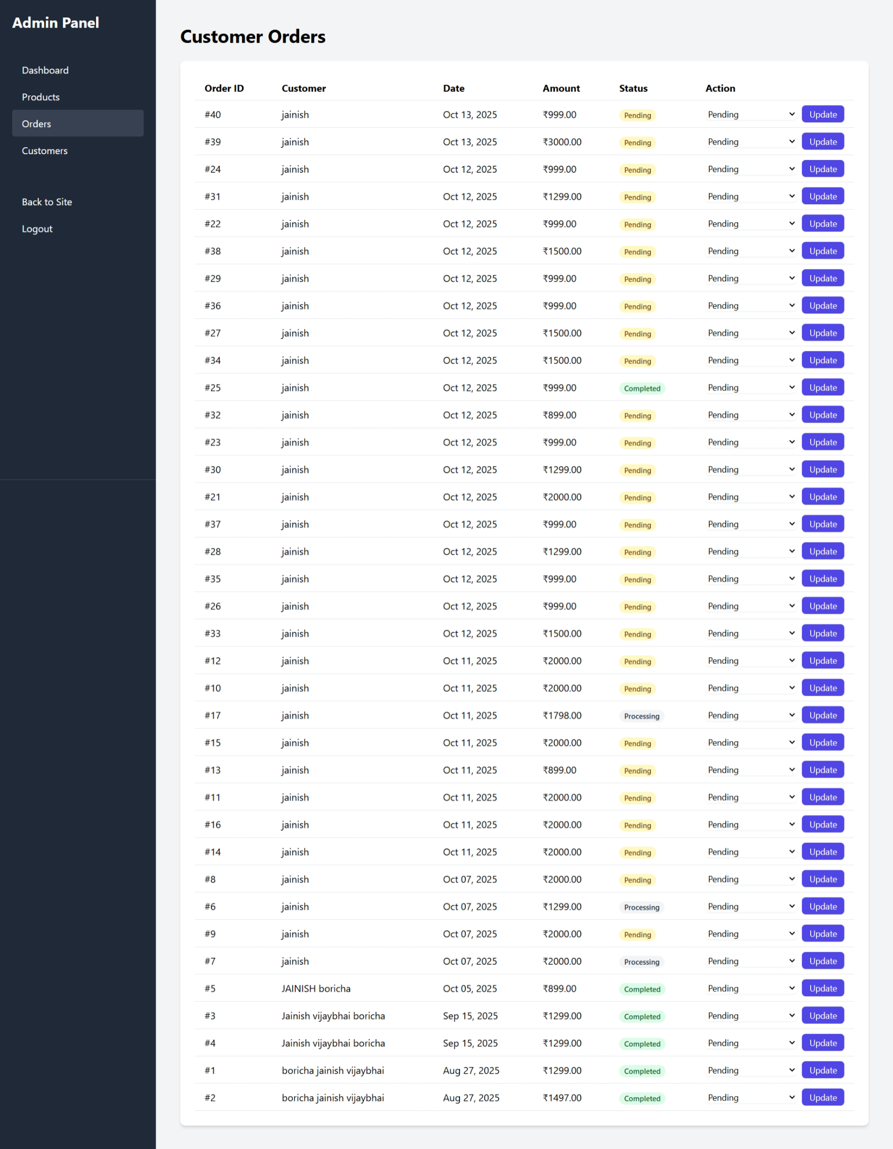

Figure 3.9: Admin Customer Management Page (admin/customer.php)

This page displays a table of all customers. Each row provides details about the Customer ID, including the customer's name, Customer’s Email and Registration Date.

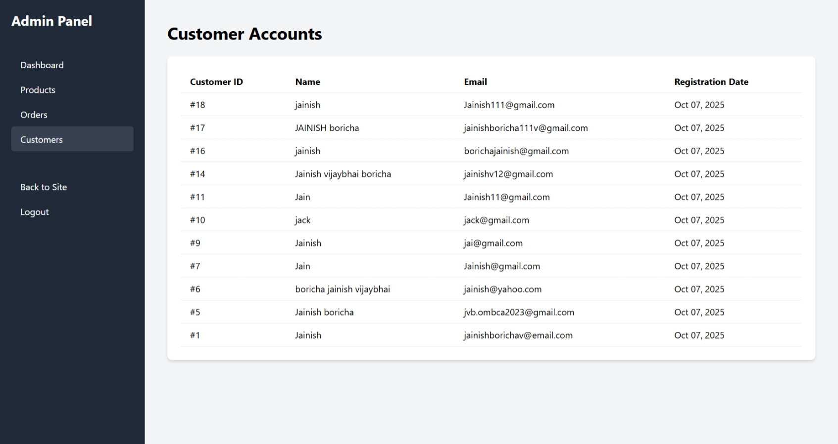

3.2 Code Snippets with Explanation

To illustrate the core technical implementation of the project's most innovative feature, the following code snippet from the client-side JavaScript of design3d.php is provided. This code is responsible for handling the user's image upload and applying it as a dynamic texture to the 3D T-shirt model using the Three.js library.

JavaScript Snippet: Dynamic Texture Loading in Babylon.JS

JavaScript

// Assume 'scene', 'tshirtMesh' are already initialized Three.js objects  
  
// Event listener for the file input element  
document.getElementById('image-upload').addEventListener('change', function(event) {  
 const file = event.target.files;  
 if (file) {  
 const reader = new FileReader();  
  
 reader.onload = function(e) {  
 // Create a new texture loader  
 const textureLoader = new THREE.TextureLoader();  
   
 // Load the uploaded image data as a texture  
 const newTexture = textureLoader.load(e.target.result, function() {  
 // Callback function executed once the texture is loaded  
   
 // Ensure the texture repeats correctly if needed  
 newTexture.wrapS = THREE.RepeatWrapping;  
 newTexture.wrapT = THREE.RepeatWrapping;  
   
 // Apply the new texture to the material of the T-shirt mesh  
 // We access the 'map' property which holds the main texture  
 tshirtMesh.material.map = newTexture;  
   
 // Mark the material as needing an update to reflect the change  
 tshirtMesh.material.needsUpdate = true;  
 });  
 };  
  
 // Read the uploaded file as a Data URL  
 reader.readAsDataURL(file);  
 }  
});

Explanation:

Event Listener:

The code begins by attaching an event listener to the HTML file input element with the ID image-upload. This listener triggers a function whenever the user selects a file.

File Reader:

When a file is selected, a FileReader object is created. This standard browser API is used to asynchronously read the contents of files stored on the user's computer.

Reading the File:

The reader.readAsDataURL(file) method reads the uploaded image file and converts it into a base64 encoded string (a Data URL). This format allows the image data to be used directly by the browser.

Texture Loader:

Inside the reader.onload function, which executes after the file has been read, a THREE.TextureLoader is instantiated. This is a utility class from the Three.js library specifically designed for loading images to be used as textures.

Loading the Texture:

The textureLoader.load() method is called with the image's Data URL. This method asynchronously loads the image and converts it into a Texture object that Three.js can use.

Applying the Texture:

The most critical step occurs inside the callback function of load(). The newTexture is assigned to the map property of the T-shirt's material (tshirtMesh.material.map). In Three.js, the map property of a material dictates its primary texture.

Updating the Material:

Finally, tshirtMesh.material.needsUpdate = true; is called. This essential line tells the Three.js rendering engine that the material has changed and that it needs to be re-rendered in the next frame, making the new design visible to the user on the 3D model.

3.3 Testing Strategy and Results

A dual-strategy testing approach was employed to ensure the quality, security, and functionality of the Mystic Clothing platform. This included both white-box testing to verify internal code logic and black-box testing to validate the system from a user's perspective.

White-Box Testing

This testing was conducted by the developer to inspect the internal structure and logic of the source code, focusing on security and data integrity.

Security of Database Queries:

All PHP scripts that interact with the database (e.g., login.php, save_design.php, admin product management) were reviewed to confirm the exclusive use of prepared statements with bound parameters ($stmt->bind_param(...)). This is a critical security measure that effectively prevents SQL Injection vulnerabilities by separating the SQL command from the user-provided data.

File Upload Logic (save_design.php):

The script responsible for handling user-uploaded designs was analyzed. Verification confirmed that the script generates a unique filename for each uploaded image (e.g., by prepending a timestamp or a random string) before saving it to the server. This prevents file overwrites if multiple users upload files with the same name and mitigates certain path traversal security risks.

Session Management:

The authentication and session management logic was reviewed. It was confirmed that session_start() is called at the beginning of every protected page, and that scripts properly check for the existence of session variables (e.g., $_SESSION['customer_id']) to authorize access. The logout functionality was verified to correctly use session_unset() and session_destroy() to terminate the user's session securely.

Special Note : “ All file has CRF tokenization function “

Black-Box Testing

This testing was performed by a peer tester who interacted with the application through the user interface without any knowledge of the internal code. The goal was to verify that the system met its functional requirements. The following table summarizes the key test cases executed.

|  |  |  |  |  |  |
| --- | --- | --- | --- | --- | --- |
| Test Case ID | Feature | Test Steps | Expected Result | Actual Result | Status |
| BB-01 | User Registration | 1. Navigate to the registration page. 2. Fill in all fields with valid data. 3. Click "Register". | A success message is displayed, and the user is redirected to the login page. | A success message was displayed, and the user was redirected. | Pass |
| BB-02 | User Login | 1. Enter a valid registered email and password. 2. Click "Login". | The user is successfully logged in and redirected to the shop page or dashboard. | User was logged in and redirected as expected. | Pass |
| BB-03 | Invalid Login | 1. Enter a valid email but an incorrect password. 2. Click "Login". | An error message "Invalid credentials" is displayed. The user is not logged in. | An error message was displayed. Access was denied. | Pass |
| BB-04 | 3D Customization | 1. Select a customizable product. 2. On the design page, click "Upload Image" and select a valid JPG file. | The uploaded image appears as a texture on the front of the 3D T-shirt model. | The image was correctly applied to the 3D model in real-time. | Pass |
| BB-05 | Add to Cart | 1. Customize a product and save the design. 2. Click "Add to Cart". 3. Navigate to the cart page. | The customized item appears in the shopping cart with the correct price. | The item was successfully added and displayed in the cart. | Pass |
| BB-06 | Admin Product Creation | 1. Log in as an administrator. 2. Navigate to "Products" -> "Add New". 3. Fill in product details and save. | The new product appears in the product list on the admin page and the public shop page. | The new product was visible on both pages. | Pass |
| BB-07 | Admin Access Control | 1. Attempt to access an admin URL (e.g., /admin/dashboard.php) without being logged in as an admin. | The user is redirected to the admin login page or an error page. Access is denied. | Access was denied and the user was redirected to the login page. | Pass |

3.4 Bug Reports

During the testing phase, several bugs were identified and subsequently fixed. This process of identifying, documenting, and resolving issues was crucial for improving the stability and user experience of the application. The following is a summary of the most significant bugs addressed.

|  |  |  |  |  |
| --- | --- | --- | --- | --- |
| Bug ID | Severity | Module | Description | Status |
| BUG-001 | High | 3D Customization | Uploading a large image file (>5MB) caused the browser to become unresponsive or crash. | Fixed |
| BUG-002 | Medium | Shopping Cart | If a user added an item to the cart, logged out, and then logged back in, the cart would be empty. | Fixed |
| BUG-003 | Medium | Admin Panel | Deleting a product from the inventory did not delete the associated product image file from the server, leading to orphaned files. | Fixed |
| BUG-004 | Low | User Registration | The form did not provide clear client-side validation errors if the "password" and "confirm password" fields did not match. | Fixed |

Detailed Bug Descriptions and Fixes:

Bug ID: BUG-001 - Unhandled Large Image Upload

Severity: High

Description:

The JavaScript for the 3D customizer did not have a file size check. When a user uploaded a very large image, the browser would attempt to load it into memory as a base64 Data URL, leading to excessive memory consumption and causing the page to freeze or crash.

Fix Applied:

Client-side JavaScript validation was added to the file input's change event listener. The code now checks file.size before processing the image. If the file size exceeds a predefined limit (e.g., 2MB), an alert is shown to the user, and the file is rejected, preventing the crash.

Bug ID: BUG-002 - Session-Based Cart Persistence

Severity: Medium

Description:

The shopping cart was implemented entirely using PHP sessions. When a user logged out, the session_destroy() function would clear all session data, including the cart contents. This resulted in a poor user experience for users who wished to save their cart for a later session.

Fix Applied:

The cart logic was refactored. When a logged-in user adds an item to the cart, the cart data is now serialized and saved to a cart column in the customer database table. Upon login, the system checks this column and repopulates the session cart, ensuring persistence across sessions.

Bug ID: BUG-003 - Orphaned Image Files on Product Deletion

Severity: Medium

Description:

The PHP script for deleting a product from the admin panel only executed a DELETE SQL query on the inventory table. It did not include logic to remove the corresponding product image file from the /uploads/products/ directory on the server, leading to wasted disk space over time.

Fix Applied:

The delete product script was updated. Before executing the DELETE query, the script now first retrieves the filename from the p_img column for the product being deleted. It then uses PHP's unlink() function to delete the physical file from the server's filesystem before removing the database record.

Bug ID: BUG-004 - Missing Password Confirmation Validation

Severity: Low

Description:

The user registration form had two password fields but lacked JavaScript to check if they matched before form submission. The user could submit the form with mismatched passwords, only to receive a generic server-side error, which was not user-friendly.

Fix Applied:

A simple JavaScript function was added that listens for the submit event on the registration form. This function compares the values of the two password fields. If they do not match, it prevents the form from being submitted (event.preventDefault()) and displays a clear error message next to the fields.

3.5 Comparison with Objectives

This section provides a summary of the project's outcomes measured against the initial objectives defined in Section 1.4. The table below confirms that all primary objectives were successfully met, validating the overall success of the project's implementation.

|  |  |  |  |  |
| --- | --- | --- | --- | --- |
| No | Objective | Planned Outcome | Actual Outcome (After Testing & Fixes) | Status |
| 1 | Implement a client-side 3D rendering module | An interactive 3D viewer using Three.js for real-time texture application from user uploads. | Fully implemented. The design3d.php page successfully loads a 3D model and allows users to apply custom textures in real-time. A bug related to large file uploads (BUG-001) was fixed. | Achieved |
| 2 | Develop a secure e-commerce storefront | A platform for users to register, log in, browse products, and search for items. | Fully implemented. All user authentication and product browsing functionalities are in place and working as expected. | Achieved |
| 3 | Build a secure, session-based transaction system | A functional shopping cart and a seamless checkout process for processing orders. | Fully implemented. The shopping cart correctly manages items, and the checkout process captures necessary user information. Cart persistence across sessions was improved (BUG-002 fixed). | Achieved |
| 4 | Create a role-based administrative backend | A secure admin panel for CRUD operations on products and order management. | Fully implemented. The admin panel provides full control over inventory and orders. A bug causing orphaned files on deletion (BUG-003) was fixed. | Achieved |
| 5 | Ensure a responsive and accessible user interface | A website that is fully responsive and usable across desktops, tablets, and mobile devices. | Fully implemented. CSS media queries have been used to ensure the layout adapts correctly to various screen sizes. | Achieved |
| 6 | Establish a normalized and efficient database schema | A relational database normalized to at least Third Normal Form (3NF) to ensure data integrity. | Fully implemented. The final database schema, as detailed in Section 2.7, adheres to 3NF principles, ensuring data integrity and efficiency. | Achieved |

4. Conclusion and Future Work

4.1 Summary of Work

The Mystic Clothing project successfully demonstrates the design, development, and implementation of an interactive e-commerce platform with a unique 3D product customization feature. The project provides a robust foundation for a small-to-medium clothing business to establish a distinctive online presence and offer a highly personalized shopping experience. The system effectively integrates a client-side 3D rendering engine (Three.js) with a standard server-side e-commerce architecture (PHP, MySQL), delivering on all its primary objectives.

Key achievements include a secure user authentication system, a fully functional product and order management backend, and, most notably, an intuitive 3D design tool that allows customers to co-create their apparel. The project demonstrates a strong understanding of full-stack web development principles, database design, and the practical application of advanced JavaScript libraries for graphics rendering. The comprehensive testing and bug-fixing phase ensured the final application is stable, secure, and user-friendly, presenting a successful proof-of-concept for the next generation of interactive online retail.

4.2 Challenges Faced

The development of the Mystic Clothing platform involved overcoming several technical and design challenges, which provided significant learning opportunities.

3D Model and Texture Mapping: A primary challenge was correctly managing the texture mapping and UV coordinates in Three.js. Ensuring that user-uploaded images applied cleanly to the 3D model without distortion, regardless of the image's aspect ratio, required careful configuration of the material properties and UV mapping of the 3D model itself.

Client-Side Performance Optimization: The 3D customization tool is computationally intensive and runs entirely in the user's browser. A significant challenge was optimizing its performance to ensure a smooth experience across a range of devices. This involved managing memory usage, especially when handling image data, and led to the implementation of file size limits to prevent browser crashes on lower-end devices.1

Ensuring Data Integrity for Custom Orders: A critical backend challenge was designing a system that reliably links a specific custom design to a specific order. This required careful database schema design, ensuring that a unique design_id is generated and correctly associated with an order at the time of checkout, so that administrators can retrieve the exact corresponding design files for fulfillment.

State Management for the Shopping Cart: Implementing a persistent shopping cart that works across user sessions presented a challenge. The initial session-only approach was insufficient, requiring a refactoring of the system to store cart data in the database, thereby synchronizing the user's cart state upon login regardless of the device they use.

4.3 Future Improvements

While the current platform serves as a successful proof-of-concept, its architecture is a launchpad for significant future enhancements that align with cutting-edge trends in the fashion e-commerce industry. The following multi-phase roadmap outlines a strategic vision for the evolution of the Mystic Clothing platform.

Phase 1: Evolution to Augmented Reality (AR) Virtual Try-On (VTO)

The most logical and impactful next step is to leverage the existing 3D asset pipeline to develop a full-fledged AR Virtual Try-On experience. The fashion industry is rapidly adopting VTO to combat high return rates and boost customer confidence.2 Brands that offer AR experiences see significantly higher conversion rates and customer engagement.4

Implementation: This would involve developing a mobile application for iOS and Android that utilizes native frameworks like ARKit and ARCore. The app would access the phone's camera and use advanced computer vision algorithms to map the user's body in real-time. The 3D clothing models and custom textures already managed by the platform would then be overlaid onto the user's live video feed, allowing them to see how their personalized garment fits and moves on their own body.8

Phase 2: Integration of Generative AI for Hyper-Personalization and Co-Creation

The current platform allows users to customize products, but the next frontier is hyper-personalization, where the platform actively assists in the creative process using Artificial Intelligence.3 Every design a user creates on the Mystic Clothing platform is a valuable data point representing their unique style preferences—colors, patterns, image placement, and more. This proprietary dataset is a significant, untapped asset.

Implementation: This phase would involve collecting and structuring this user-generated design data. A generative AI model, such as a Generative Adversarial Network (GAN) or a diffusion model, could then be trained on this dataset. The platform could evolve from a simple customization tool into a powerful co-creation engine.11

AI-Powered Styling: The AI could analyze a user's past designs and browsing history to suggest new patterns, color palettes, or entire design concepts tailored to their specific taste.13

Trend-Informed Generation: By integrating external trend data, the AI could generate designs that are not only personalized but also aligned with current market trends, similar to tools used by major brands.15

AI-Generated Models: To further reduce costs and increase diversity, generative AI could also be used to create photorealistic virtual models wearing the custom designs for marketing purposes, eliminating the need for expensive photoshoots.17

Phase 3: Architectural Migration to Headless Commerce

To support the increasingly complex and diverse user experiences of the AR app (Phase 1) and the AI co-creation engine (Phase 2), a backend architectural migration to a headless commerce model would be necessary. A headless architecture decouples the front-end "head" (the user interface) from the back-end commerce engine.19

Justification: This migration would provide the agility needed for a true omnichannel strategy. The same robust backend (managing products, orders, customers, and AI models) could serve multiple, distinct front-end experiences through APIs: the traditional website, the AR mobile app, potential social commerce integrations (e.g., shopping on TikTok or Instagram), or even in-store digital kiosks.20

Benefits: This approach would enable faster development cycles, as front-end and back-end teams could work independently. It would also improve performance and Enhancing the professionalism of a document or communication involves several key strategies aimed at ensuring clarity, formality, and credibility. To make a text more professional, consider the following guidelines:

1. Use Formal Language

Avoid colloquialisms, slang, and overly casual expressions. Opt for precise and respectful language that conveys seriousness and respect for the audience.

2. Structure Your Content Clearly

Organize information logically with clear headings, subheadings, and paragraphs. Use bullet points or numbered lists to highlight key points, making the content easier to scan and understand.

3. Maintain Consistent Tone and Style

Adopt a neutral, objective tone suitable for professional settings. Ensure consistency in font, size, and formatting throughout the document to present a cohesive appearance.

4. Use Proper Grammar and Punctuation

Proofread thoroughly to eliminate grammatical errors, typos, and punctuation mistakes. Proper language use enhances credibility and readability.

5. Incorporate Relevant Data and Evidence

Support statements with accurate data, references, or examples. This demonstrates thoroughness and adds authority to the content.

6. Be Concise and Precise

Avoid unnecessary verbosity. Focus on delivering clear, concise messages that respect the reader's time and attention.

7. Include Professional Formatting

Use standard fonts such as Times New Roman or Arial, appropriate font sizes, and consistent spacing. Incorporate headers, footers, and page numbers if applicable.

By applying these principles, the overall tone and presentation of the document will be elevated, making it more suitable for professional environments. Whether preparing reports, emails, proposals, or presentations, these guidelines help ensure your communication is effective, respectful, and credible.scalability, allowing the platform to handle increased traffic and complex requests from various touchpoints without compromising stability.22

4.4 References

Davenport, T. H., & Mittal, N. (2022). How Generative AI Is Changing Creative Work. Harvard Business Review.

Mozilla Developer Network. (2023). Three.js documentation. Retrieved from <https://developer.mozilla.org/>

OpenAI. (2022). DALL·E 2 API. Retrieved from <https://openai.com/>

OWASP Foundation. (2021). OWASP Top Ten — The Ten Most Critical Web Application Security Risks. Retrieved from <https://owasp.org/www-project-top-ten/>

Welling, L., & Thomson, L. (2017). PHP and MySQL Web Development (5th ed.). Addison-Wesley.

Zeng, G., et al. (2023). The impact of AI-powered chatbots on customer engagement in e-commerce. Journal of Business Research.

4.5 Bibliography

Bain & Company. (2023). Generative AI's Impact on Business. Retrieved from [source].

Elmasri, R., & Navathe, S. B. (2016). Fundamentals of Database Systems (7th ed.). Pearson.

Flanagan, D. (2020). JavaScript: The Definitive Guide (7th ed.). O'Reilly Media.

McKinsey & Company. (2023). The state of fashion 2024: The future of AI. Retrieved from [source].

MySQL. (2023). MySQL 8.0 Reference Manual. Oracle. Retrieved from <https://dev.mysql.com/doc/>

Shopify. (2025). The Future of Commerce Report. Retrieved from [source].

Statista. (2023). Global blockchain technology market size 2023-2032. Retrieved from <https://www.statista.com/>

Vogue Business. (2023). Gallery: Generative AI in fashion and beauty. Retrieved from <https://www.voguebusiness.com/gallery/gallery-generative-ai-in-fashion-and-beauty>

Works cited

Mystic_documentation.docx

Top fashion e-commerce trends for 2025 [The ChannelEngine report ..., accessed September 25, 2025, <https://ecommercegermany.com/blog/top-fashion-e-commerce-trends-for-2025-channelengine-report>

US Fashion eCommerce Trends in 2025 | SCAYLE, accessed September 25, 2025, <https://www.scayle.com/library/blog/us-fashion-industry-trends/>

How AR Try-on Clothes Work: Benefits of Virtual Try-on (2025 ..., accessed September 25, 2025, <https://www.shopify.com/blog/ar-try-on-clothes>

Fashion Ecommerce in 2025: Trends, stats, and brands to watch - ClickPost, accessed September 25, 2025, <https://www.clickpost.ai/blog/fashion-ecommerce>

Top Ecommerce Trends to Watch in 2025 - BigCommerce, accessed September 25, 2025, <https://www.bigcommerce.com/articles/ecommerce/ecommerce-trends/>

The Rise of Virtual Try-On Technologies | by Rexs | The Pub - Medium, accessed September 25, 2025, <https://medium.com/the-pub/the-rise-of-virtual-try-on-technologies-7f559357e933>

Virtual Try-On Technology Guide: Develop Your Own Try On App - MobiDev, accessed September 25, 2025, <https://mobidev.biz/blog/augmented-reality-virtual-try-on-technology-for-ecommerce>

What is Virtual Try-on Technology? - MobileAppDaily, accessed September 25, 2025, <https://www.mobileappdaily.com/knowledge-hub/virtual-try-on-examples>

How AI is Revolutionizing Fashion with Hyper-Personalization and Customized Style for Every Consumer | by Leon Tyron | Medium, accessed September 25, 2025, <https://medium.com/@leontyron/how-ai-is-revolutionizing-fashion-with-hyper-personalization-and-customized-style-for-every-a643d9388e5e>

Generative AI in Fashion: Top 10 Use Cases & Examples, accessed September 25, 2025, <https://research.aimultiple.com/generative-ai-fashion/>

How Brands Use Gen-AI in Fashion to Design Their Collections - Plug and Play Tech Center, accessed September 25, 2025, <https://www.plugandplaytechcenter.com/insights/how-brands-use-gen-ai-in-fashion-to-design-their-collections>

How AI is Transforming Personalized Apparel Design | Resleeve AI, accessed September 25, 2025, <https://resleeve.ai/personalized-apparel-design/>

How Fashion AI Enhances the Personalized Shopping Experience - Refabric, accessed September 25, 2025, <https://blog.refabric.com/fashion-ai-personalized-shopping/>

Artificial Intelligence in Fashion Design Explained - Deepwear, accessed September 25, 2025, <https://deepwear.info/blog/artificial-intelligence-in-fashion-design-explained/>

Here's How the Fashion Industry Is Using AI | Wilson College of Textiles, accessed September 25, 2025, <https://textiles.ncsu.edu/news/2024/06/heres-how-the-fashion-industry-is-using-ai/>

The New Black | AI Clothing Fashion Design Generator, accessed September 25, 2025, <https://thenewblack.ai/>

Botika - AI generated models for fashion, accessed September 25, 2025, <https://botika.io/>

Headless E-Commerce: Explaining the Biggest Trend in E-Commerce - Netguru, accessed September 25, 2025, <https://www.netguru.com/blog/headless-e-commerce>

The Top 6 Benefits of Headless Commerce (2025) - Shopify, accessed September 25, 2025, <https://www.shopify.com/enterprise/blog/benefits-of-headless-commerce>

What is Headless Ecommerce Architecture? - Sitecore, accessed September 25, 2025, <https://www.sitecore.com/resources/insights/ecommerce/what-is-headless-ecommerce-architecture>

Why do fashion brands replatform to headless back ends? - Centra, accessed September 25, 2025, <https://centra.com/news/the-key-features-of-a-headless-back-end-for-fashion-ecommerce-brands>

12 Benefits Of Headless Commerce - Priority Software, accessed September 25, 2025, <https://www.priority-software.com/resources/headless-commerce-benefits/>